**TUGAS UTS PENGGANTI PRAKTIKUM PKPL  
PEMBUATAN WEBSITE RENTAL MOBIL PT FAUZAN CAR RENT**



**Oleh**

**Yurhiko Arshal Fauzan  
PKPL-B  
2000018246**

**Skenario Uji PL**

Halaman pendaftaran website rental mobil docar.co.id (mengambil website yang mirip dengan dokumen kontrak karena pada website yang terdapat pada dokumen kontrak tidak memiliki form inputan)

Home Page Website

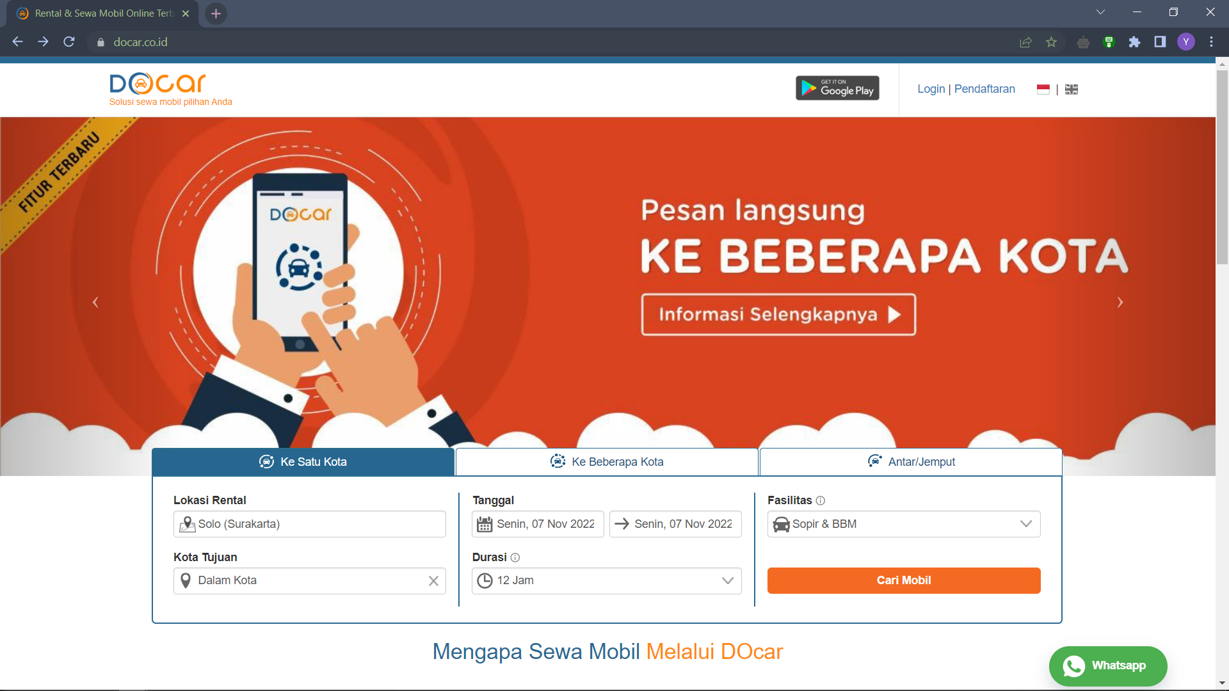

Registration Page Website

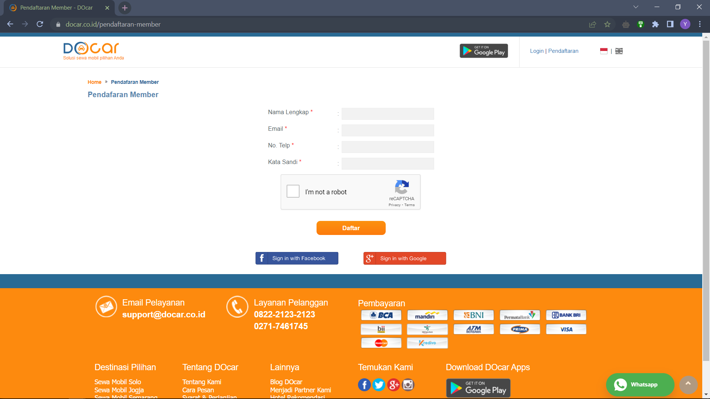

Login Page Website

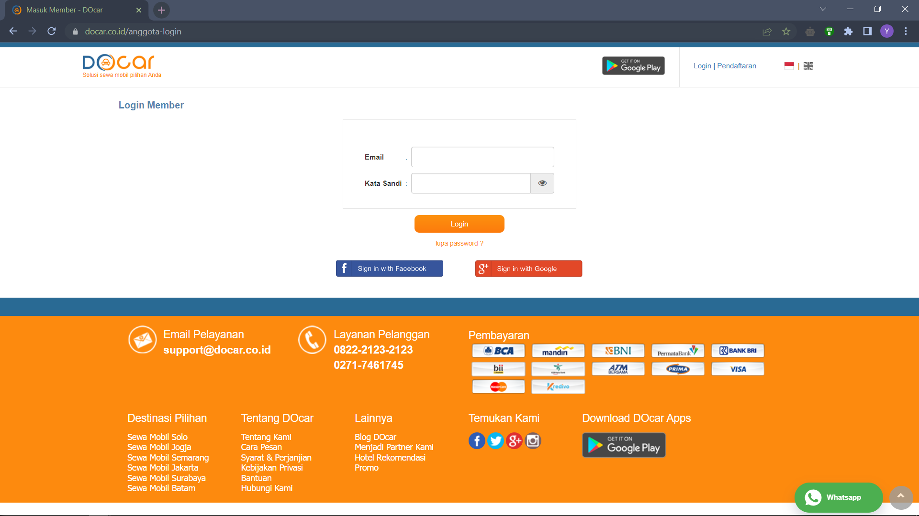

Order Page Website

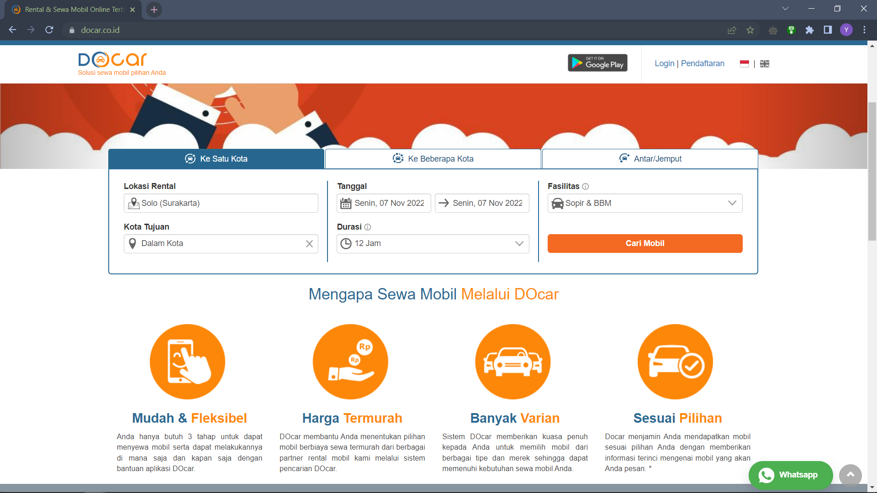

Pembuatan Skenario Uji PL

|  |  |  |  |
| --- | --- | --- | --- |
| Project Name : docar.co.id | | | Reviewed By : Yurhiko Arshal Fauzan |
| Module Name : User | | | Reviewed Date : 6 November 2022 |
| Document : | | | Approved By : |
| Author : PT Docar Rental Indonesia | | | Approved Date : |
| Created Date : | | |  |
| Scenario ID | Module | Requirement | Test Scenario |
| TS001 | User | R1.0 Docar Home Page | Check Launching Website |
| TS002 | User | R1.0 Docar Home Page | Check Navigation of Home Page |
| TS003 | User | R2.0 Docar Registration Page | Check User Registration |
| TS004 | User | R2.0 Docar Registration Page | Check Captcha |
| TS005 | User | R3.0 Docar Login Page | Check User Login |
| TS006 | User | R4.0 Docar Order Page | Check Navigation of Order Page |

**Pelaksanaan Uji PL**

Form Register



Menggunakan metode Decision Table

|  |  |  |  |  |  |  |  |  |  |
| --- | --- | --- | --- | --- | --- | --- | --- | --- | --- |
| Inputs | TC1 | TC2 | TC3 | TC4 | TC5 | TC6 | TC7 | TC8 | TC9 |
| Nama Lengkap | Yes | No | Yes | Yes | Yes | Yes | No | No | No |
| Email | Yes | Yes | No | Yes | Yes | Yes | No | Yes | Yes |
| No Telp | Yes | Yes | Yes | No | Yes | Yes | Yes | No | Yes |
| Kata Sandi | Yes | Yes | Yes | Yes | No | Yes | Yes | Yes | No |
| Captcha | Yes | Yes | Yes | Yes | Yes | No | Yes | Yes | Yes |
| Expexted Result |  | Error | Error | Error | Error | Error | Error | Error | Error |

|  |  |  |  |  |  |  |  |  |  |
| --- | --- | --- | --- | --- | --- | --- | --- | --- | --- |
| Inputs | TC10 | TC11 | TC12 | TC13 | TC14 | TC15 | TC16 | TC17 | TC18 |
| Nama Lengkap | No | Yes | Yes | Yes | Yes | Yes | Yes | No | No |
| Email | Yes | No | No | No | Yes | Yes | Yes | No | No |
| No Telp | Yes | No | Yes | Yes | No | No | Yes | No | Yes |
| Kata Sandi | Yes | Yes | No | Yes | No | Yes | No | Yes | No |
| Captcha | No | Yes | Yes | No | Yes | No | No | Yes | Yes |
| Expexted Result | Error | Error | Error | Error | Error | Error | Error | Error | Error |
| Inputs | TC19 | TC20 | TC21 | TC22 | TC23 | TC24 | TC25 | TC26 | TC27 |
| Nama Lengkap | No | No | No | No | Yes | Yes | Yes | Yes | No |
| Email | No | Yes | Yes | Yes | No | No | No | Yes | No |
| No Telp | Yes | No | No | Yes | No | No | Yes | No | No |
| Kata Sandi | Yes | No | Yes | No | No | Yes | No | No | No |
| Captcha | No | Yes | No | No | Yes | No | No | No | Yes |
| Expexted Result | Error | Error | Error | Error | Error | Error | Error | Error | Error |

|  |  |  |  |  |  |
| --- | --- | --- | --- | --- | --- |
| Inputs | TC28 | TC29 | TC30 | TC31 | TC32 |
| Nama Lengkap | No | No | No | Yes | No |
| Email | No | No | Yes | No | No |
| No Telp | No | Yes | No | No | No |
| Kata Sandi | Yes | No | No | No | No |
| Captcha | No | No | No | No | No |
| Expexted Result | Error | Error | Error | Error | Error |

Form Login



|  |  |  |  |  |  |  |  |  |
| --- | --- | --- | --- | --- | --- | --- | --- | --- |
| Inputs | TC1 | TC2 | TC3 | TC4 | TC5 | TC6 | TC7 | TC8 |
| Email | Yes | No | Yes | Yes | No | Yes | No | No |
| Kata Sandi | Yes | Yes | No | Yes | No | No | Yes | No |
| Login | Yes | Yes | Yes | No | Yes | No | No | No |
| Expected Result |  | Error | Error | Error | Error | Error | Error | Error |

Kesimpulan : Jika semua field pada form login dan register diisi maka akan berhasil login/registrasi. Tapi jika terdapat salah satu field yang kosong atau tidak diisi maka akan menampilkan output error.

1. **Diagram Path**

Source Code

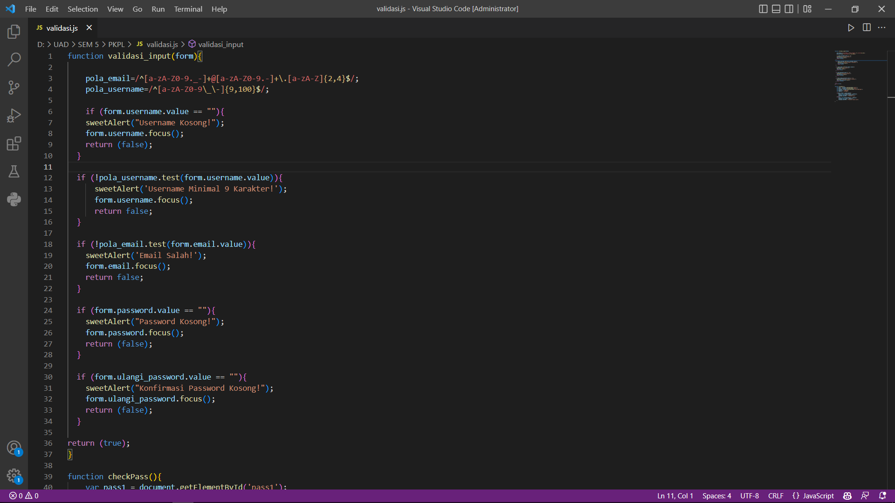

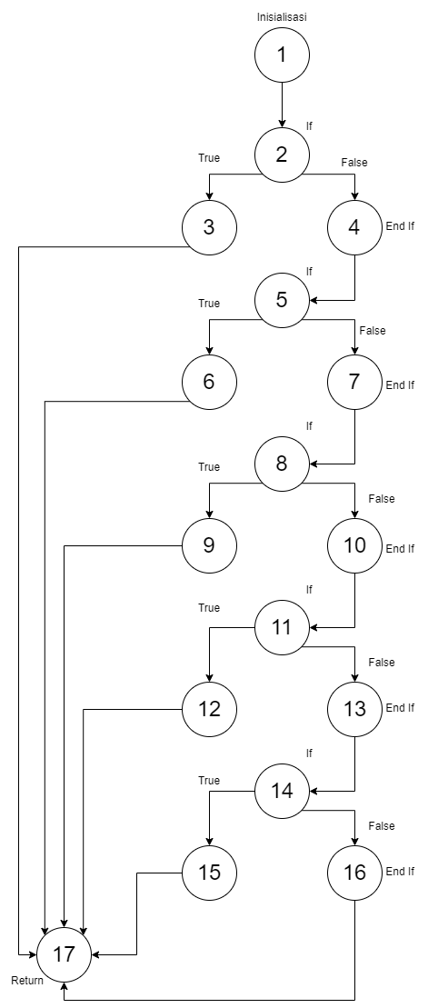

1. **Penghitungan Kompleksitas Cyclomatic**

Kompleksitas Cyclomatic [V(g)] = Jumlah Edge – Jumlah Node + 2

= 21 - 17 + 2

= 6

1. **Tabel Jalur Bebas Kompleksitas Cyclomatic**

|  |  |
| --- | --- |
| Path 1 | 1-2-4-5-7-8-10-11-13-14-16-17 |
| Path 2 | 1-2-3-17 |
| Path 3 | 1-2-4-5-6-17 |
| Path 4 | 1-2-4-5-7-8-9-17 |
| Path 5 | 1-2-4-5-7-8-10-11-12-17 |
| Path 6 | 1-2-4-5-7-8-10-11-13-14-15-17 |

1. **Skenario Pengujian**

Model Boundary Value Analysis (BVA)

|  |  |  |  |
| --- | --- | --- | --- |
| Skenario | Path | Hasil yang diharapkan | Hasil yang didapat |
| Memasukkan username, email, dan password dengan inputan yang valid | 1-2-4-5-7-8-10-11-13-14-16-17 | User bisa melakukan registrasi pada website | Berhasil |
| Hanya mengisi username saja dengan inputan yang kurang dari 9 karakter | 1-2-3-17 | Muncul popup “Username Minimal 9 Karakter!”, “Email Kosong!”, “Password Kosong!”, dan “Konfirmasi Password Kosong!” | Berhasil |
| Mengisi username saja dengan karakter lebih dari 9 | 1-2-4-5-6-17 | Muncul popup “Email Kosong!”, “Password Kosong!”, dan “Konfirmasi Password Kosong!” | Berhasil |
| Mengisi username dengan 9 karakter dan email | 1-2-4-5-7-8-9-17 | Muncul popup “Password Kosong!”, dan “Konfirmasi Password Kosong!” | Berhasil |
| Mengisi username dengan 9 karakter, email, dan password | 1-2-4-5-7-8-10-11-12-17 | Muncul popup “Konfirmasi Password Kosong!” | Berhasil |
| Mengisi username dengan 9 karakter, email, dan password | 1-2-4-5-7-8-10-11-13-14-15-17 | Muncul popup “Konfirmasi Password Kosong!” | Berhasil |

1. **Hasil Uji White Box**

Uji white box dimulai dari pembuatan diagram path dari source code. Lalu dari diagram path tersebut dihitung cyclomatic complexity dan didapati pengujian yang harus dilakukan yaitu berjulan 4 (jalur). Dari hasil pengujian menggunakan BVA, tidak ditemukan error pada tiap jalur yang telah diuji.

1. **Hasil Uji Black Box**

Dari pengujian yang telah dilakukan, didapati bahwa dari 6 pengujian yang dilakukan tidak ada fungsionalitas yanh error atau gagal.